**Example: Reservation Management**

Marty Ford is an operations analyst for Piedmont Commuter Airlines (PCA). Recently, Marty was asked to make a recommendation on how many reservations PCA should book on Flight 343 – a flight from a small regional airport in New England to a major hub at Boston’s Logan airport. The plane used on Flight 343 is a small twin-engine turbo-prop with 19 passenger seats available. PCA sells nonrefundable tickets for Flight 343 for $150 per seat.

Industry statistics show that for every ticket sold for a commuter flight, a 0.10 probability exists that the ticket holder will not be on the flight. Thus, if PCA sells 19 tickets for this flight, there is a fairly good chance that one or more seats on the plane will be empty. Of course, empty seats represent lost potential revenue to the company. On the other hand, if PCA overbooks this flight and more than 19 passengers show up, some of them will have to be bumped to a later flight.

To compensate for the inconvenience of being bumped, PCA gives these passengers vouchers for a free meal, a free flight at a later date, and sometimes also pays for them to stay overnight in a hotel near the airport. PCA pays an average of $325 (including the cost of lost goodwill) for each passenger that gets bumped. Marty wants to determine if PCA can increase profits by overbooking this flight and, if so, how many reservations should be accepted to produce the maximum average profit. To assist in the analysis, Marty analyzed market research data for this flight that reveals the following probability distribution of demand for this flight:

|  |  |  |  |  |  |  |  |  |  |  |  |  |
| --- | --- | --- | --- | --- | --- | --- | --- | --- | --- | --- | --- | --- |
| Seats  Demanded | 14 | 15 | 16 | 17 | 18 | 19 | 20 | 21 | 22 | 23 | 24 | 25 |
| Probability | 0.03 | 0.05 | 0.07 | 0.09 | 0.11 | 0.15 | 0.18 | 0.14 | 0.08 | 0.05 | 0.03 | 0.02 |

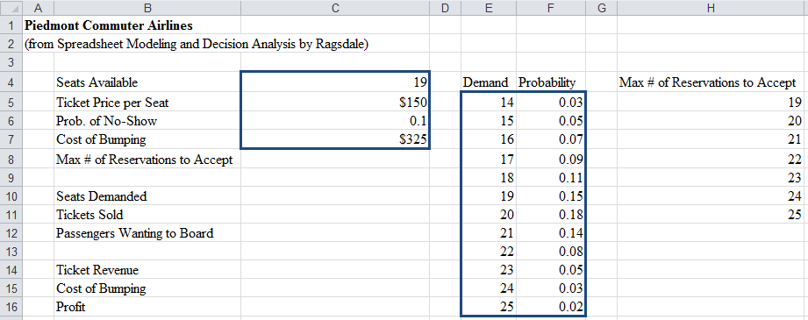**Specify the following @Risk Model in Excel:**

**Choose simulation settings:**

Iterations = _________

Simulations = _________

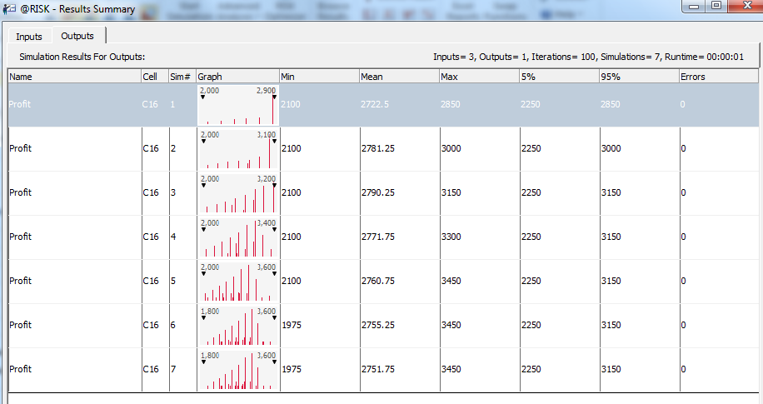**@Risk Results Summary:**

What’s the optimal maximum # of reservations to accept?